**Serially Interfaced**

**8-Digit LED Display Drivers**

**Overview**

MAX7219 MAX7221 Maxim's MAX7219 and MAX7221 integrated circuits are serial interface display controllers. These components are capable of driving up to 8 7-Segment displays with decimal point or 64 LEDs while ensuring multiplexing between the different digits as well as the decoding of the values ​​to be displayed.

Compared to the MAX7219, the MAX7221 is fully SPI, QSPI and Microwire compatible. Also, its segment controllers have a limited slew rate to reduce electromagnetic interference.

Driving this type of display with conventional components (transistors for multiplexing and BCD decoders - 7 segments for decoding) is not complicated to achieve but particularly tedious. Indeed, the number of necessary components and outputs required for their control microcontroller side is much higher.

[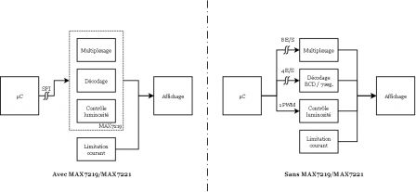](https://www.idreammicro.com/public/posts/max7219-7221/Affichage_7_segments_versus.png)

**Wiring diagram**

Despite the use of an SPI type bus, the communication is unidirectional (master to slave only). Driving a MAX7219/MAX7221 requires only three signals:

* DIN : Serial data input
* /CS : Data validation entry
* CLK : Clock Input.

Note that the 7-segment displays must be common cathode such as Liteon LTS547AHR, Kingbright SC04-11EWA or Vishay TDSR1360.

[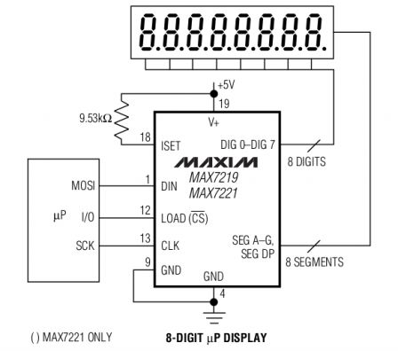](https://www.idreammicro.com/public/posts/max7219-7221/MAX7219_-_Typical_Application_Circuit.png)

**SPI Configuration**

The SPI bus must be configured in mode 0 (CPOL & CPHA to 0 at reset) as indicated by the timing diagram below

[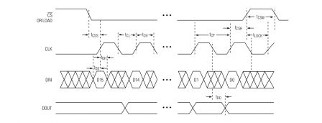](https://www.idreammicro.com/public/posts/max7219-7221/MAX7219_-_Timing_Diagram.png)

**How to drive This IC**

Data

Communication with the MAX7219/MAX7221 is done using 16-bit serial data. The 8 MSB identify the address of the target register while the 8 LSB indicate the value to be assigned to the register.

[MAX7219 / MAX7221 - Serial Data Format](https://www.idreammicro.com/public/posts/max7219-7221/MAX7219_-_Serial_Data_Format.png)

Registers

The MAX7219/MAX7221 are controlled by writing values in different registers, each with a specific role.

[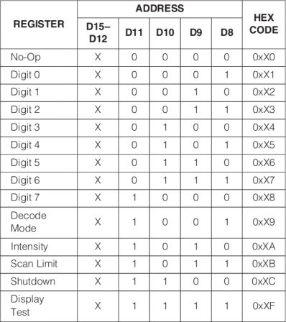](https://www.idreammicro.com/public/posts/max7219-7221/MAX7219_-_Register_Address_Map.png)

Turn On / Off

The MAX7219/MAX7221 can be turned on or off via the SHUTDOWN Register.

[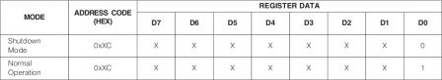](https://www.idreammicro.com/public/posts/max7219-7221/MAX7219_-_Shutdown_Register_Format.png)

Decode Mode

The MAX7219/MAX7221 offer two modes of operation, with or without decoding values. The decode mode is configurable digit by digit via the Decode Mode register.

[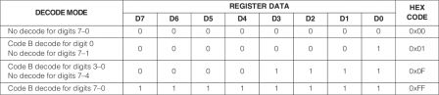](https://www.idreammicro.com/public/posts/max7219-7221/MAX7219_-_Decode_Mode_Register_Examples.png)

With Decode Mode

With value decoding, the MAX7219/MAX7221 displays predefined characters according to the table below.

[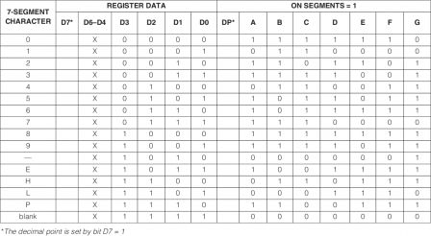](https://www.idreammicro.com/public/posts/max7219-7221/MAX7219_-_Code_B_Font.png)

Without Decode Mode

Without decoding, each bit corresponds to a segment. If the bit is 0, the corresponding segment is off. If the bit is 1, the corresponding segment is on. The bit / segment correspondences are detailed in the table below.

[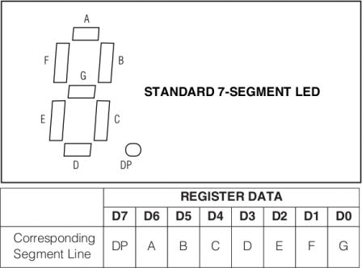](https://www.idreammicro.com/public/posts/max7219-7221/MAX7219_-_Segment_Lines.png)

With and Without Decode Mode

If you want to display a character from the list of predefined characters above, it is easier to use the mode with decoding. On the other hand, if one wishes to display an undefined character in this list, the mode without decoding is necessary.

For example, if you want to display the character 2 on the digit 0, it is necessary to turn on the segments A, B, D, E and G:

[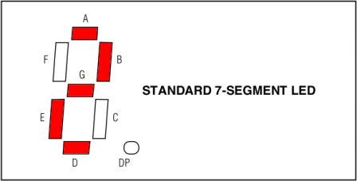](https://www.idreammicro.com/public/posts/max7219-7221/MAX7219_-_Segment_Lines_ON.png)

By using the decoded mode, assigning a value to a digit is very natural: to display the character 2 on the digit 0, write the value 2 in the Digit 0 register.

In spite of using the mode without decoding, to display the character 2 on the digit 0 amounts to turning on the segments A, B, D, E and G while writing the value 0b01101101 in the register Digit 0, each bit with 1 corresponding to a lit segment. It must be admitted that it is much less natural...

LIGHT INTENSITY

The light intensity of the segments or LEDs is adjustable via the Intensity register. If the first level is barely legible indoors with natural lighting, the latter is much more without dazzling. So each one does refine this parameter according to its conditions of use and constraints of electrical consumption.

[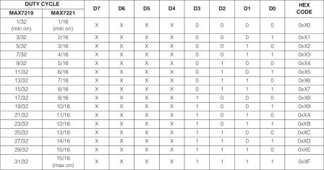](https://www.idreammicro.com/public/posts/max7219-7221/MAX7219_-_Intensity_Register_Format.png)

Number of digits

The number of digits controlled by the MAX7219/MAX7221 is configurable via the Scan Limit register, from 0 to 8 digits.

[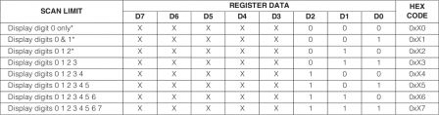](https://www.idreammicro.com/public/posts/max7219-7221/MAX7219_-_Scan-Limit_Register_Format.png)

Display test

The MAX7219/MAX7221 offers a test mode to turn on all segments or LEDs via the Display Test register. This mode allows both the operation of the MAX7219 and that of the display to be tested.

[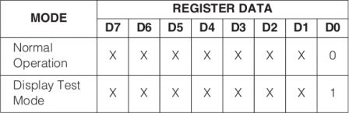](https://www.idreammicro.com/public/posts/max7219-7221/MAX7219_-_Display_Test_Register_Format.png)

Typical Application

A typical use of a MAX7219/MAX7221 could be to display characters 0 to 7 respectively on digits 0 to 7, while setting the brightness to the maximum and enabling decoding on all digits.

[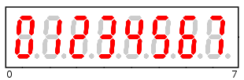](https://www.idreammicro.com/public/posts/max7219-7221/MAX7219_-_8_digits.png)

The procedure is as follows:

1. Setting the number of digits implemented:

Scan Limit (0x0B) = 0x07.

2. Adjusting the brightness:

Intensity (0x0A) = 0x0F.

3. Decoding activation:

Decode Mode (0x09) = 0xFF.

4. Write values from digits 0 to 7:

Digit 0 (0x01) = 0x00,

[...]

Digit 7 (0x08) = 0x07.

5. Lighting the display:

Shutdown (0x0C) = 0x01.